**Homework 2**

Remember that your programs must read the data from the text files exactly as they appear. You may not edit the text files to make them more convenient for SAS. Turn in the code, log file and output. If any of these 3 items is missing then you will not be graded for that question. Use the snipping tool instead of screen shots and make sure the font is large enough for me to read.

1. Refer to the CATS1 dataset. Write a SAS program to read the data file from your USB with an INFILE statement and print the dataset. There should be eight observations and two variables.

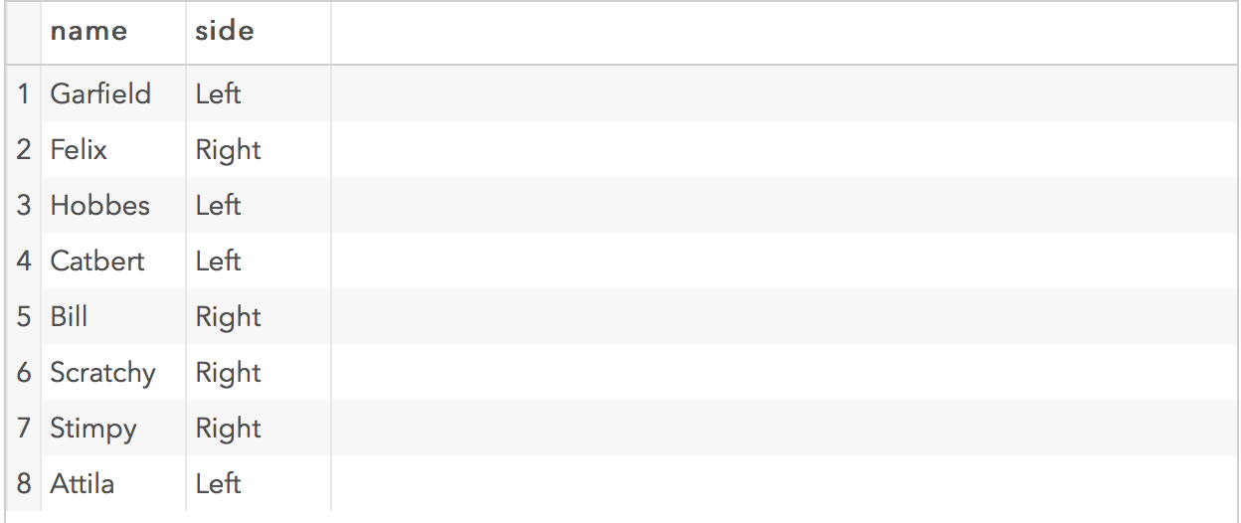

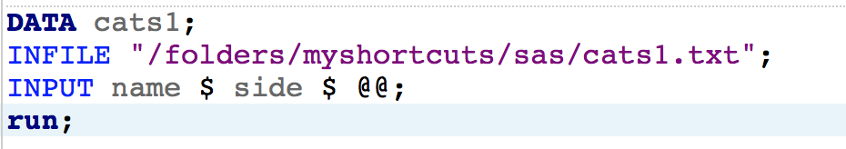

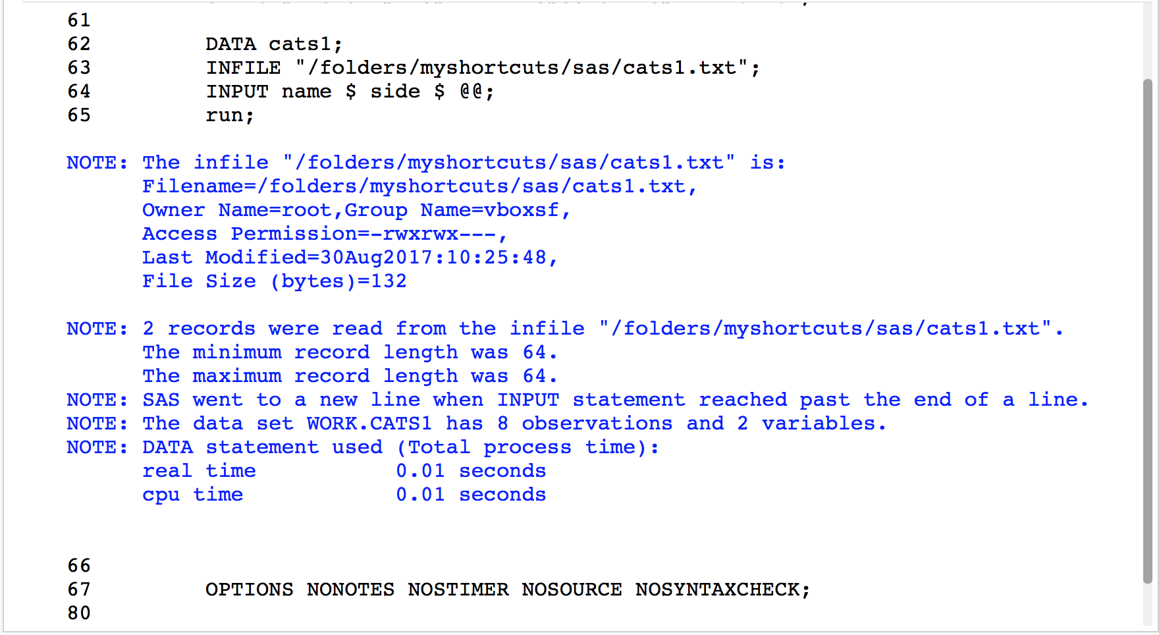

2. Refer to the DOGS1 dataset. Write a SAS program to read the data file from your USB with an INFILE statement and print the dataset. There should be 25 observations and six variables.

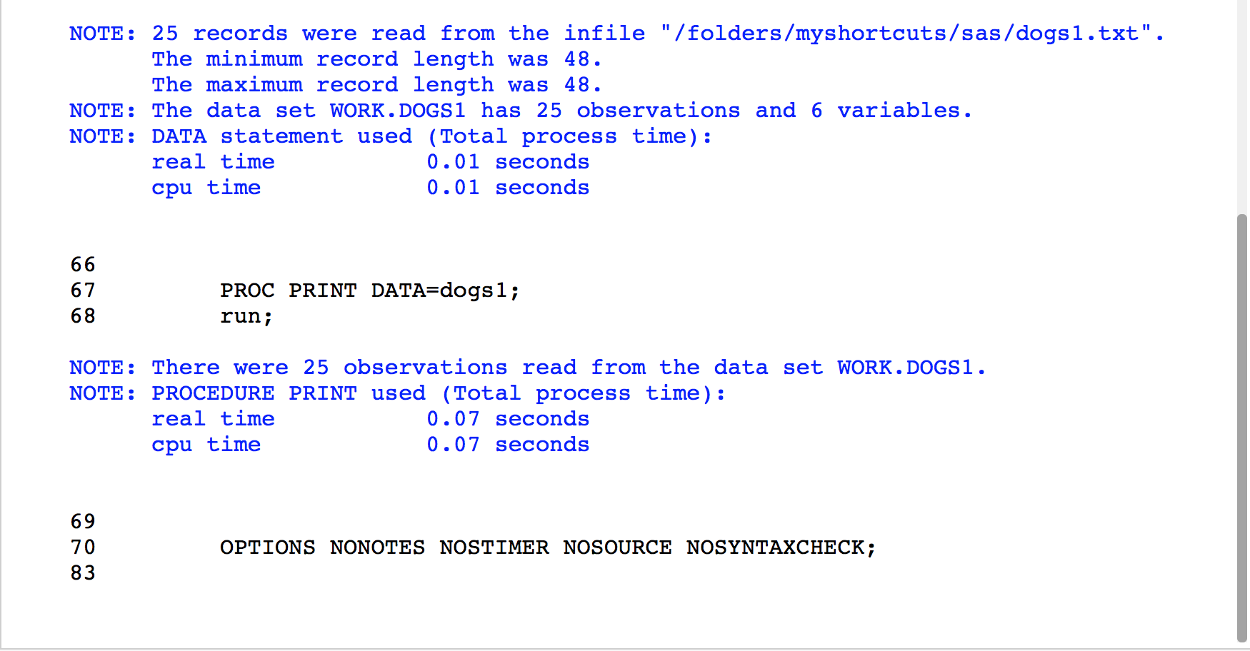

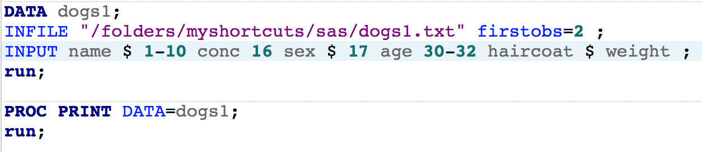

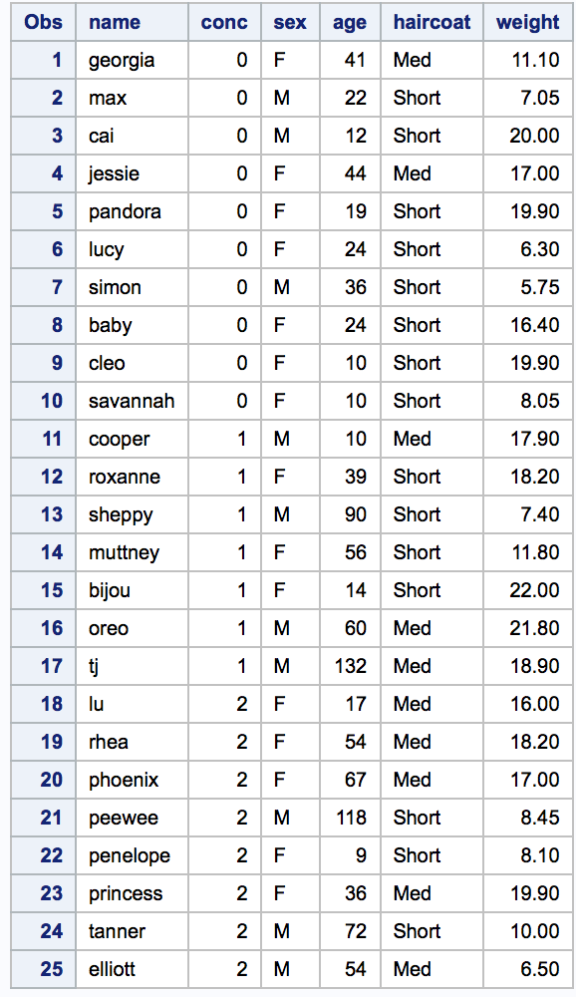

4. Refer to the grades below. Write a SAS program which uses a DATALINES command, not an INFILE statement and print the dataset. Copy and paste the numbers from the text file into your SAS program.

Ann/84/90/A-/0

Bill/78/84/B/0

Cathy/95/89/A/1

David/84/88/B+/1

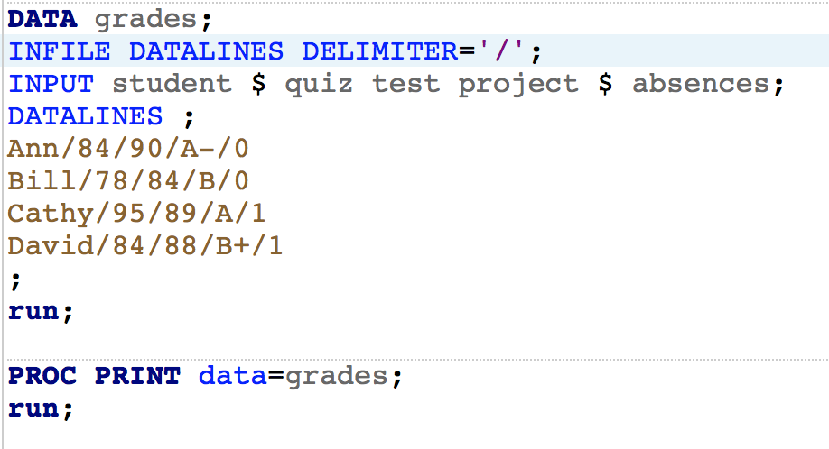

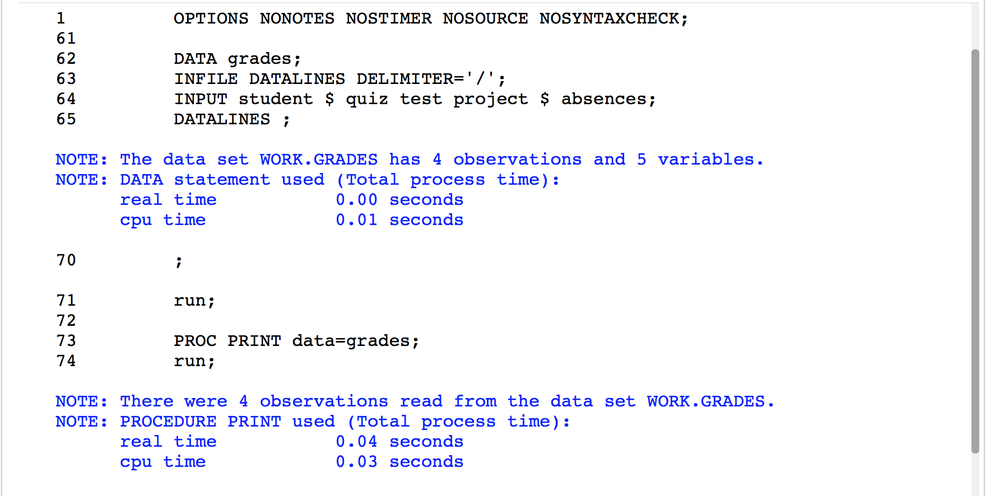

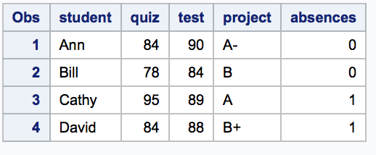

5. Refer to the SOCCER dataset. Write a SAS program to read the data file from your USB with an INFILE statement and print the dataset. Read the feet and inches in the heights of the players as two separate variables. There should be 32 observations and 8 variables. Make sure that your program correctly interprets Lynn Pattishall’s jersey number as 00. The variables are: number firstname lastname code feet inches level jersey

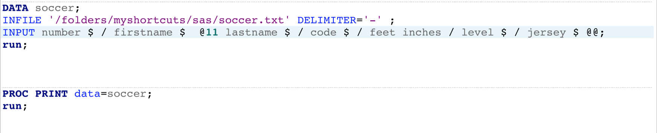

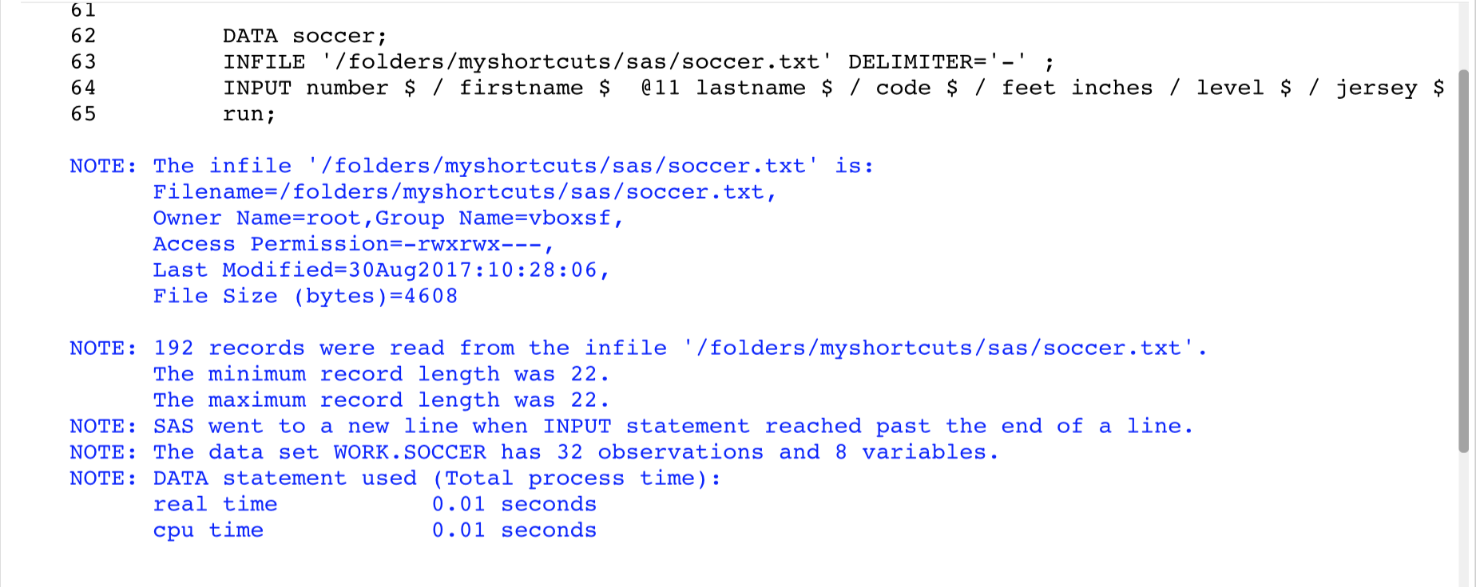

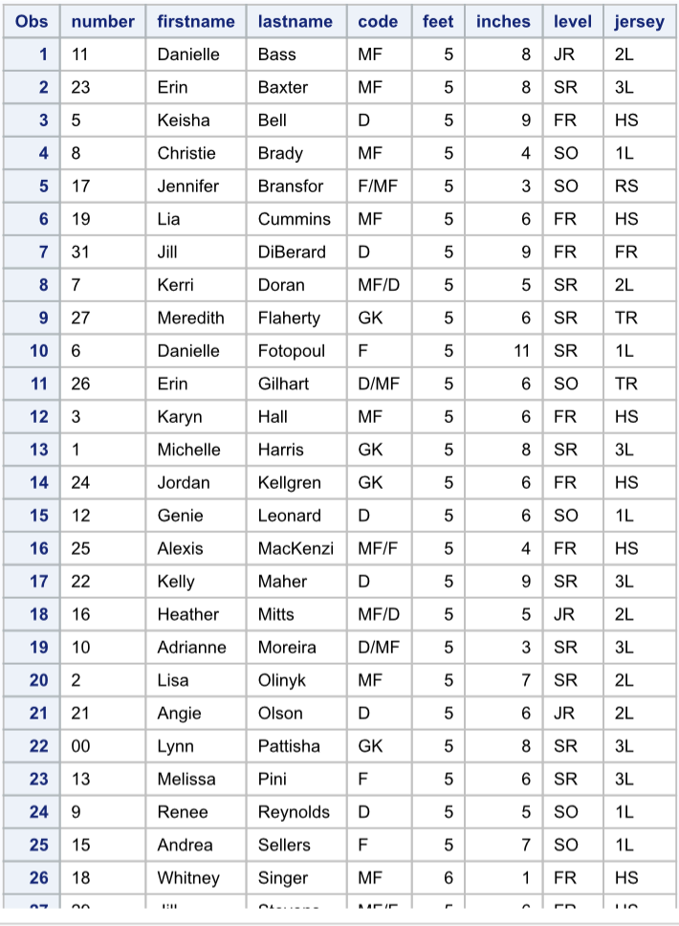

6. Refer to the CATS3 dataset. Write a SAS program to read the data file from your USB with an INFILE statement, write a permanent SAS dataset onto your USB, and print the dataset. There should be 8 observations and five variables.

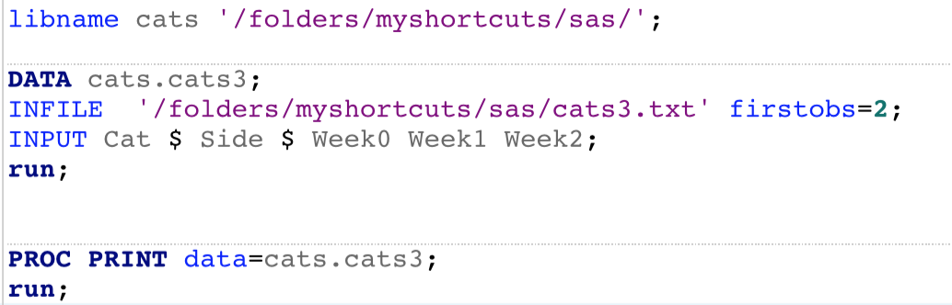

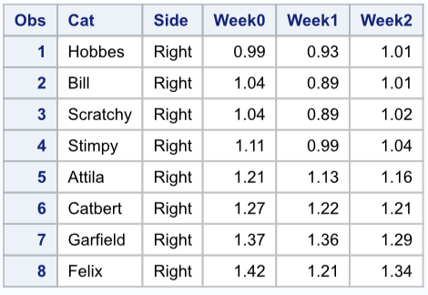

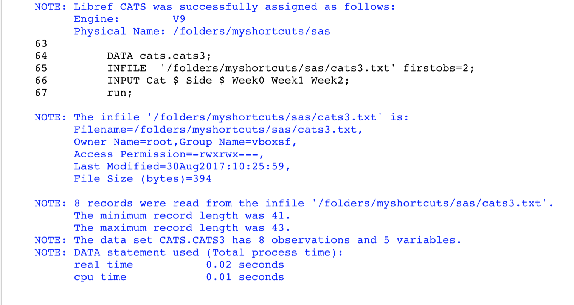

9. Use stocks.txt which contains a stock symbol, a price, and the number of shares.

1. Using this raw data file, create a temporary SAS data set (Portfolio). Choose your own variable names for the stock symbol, price, and number of shares. In addition create a new variable (call it Value) equal to the stock price times the number of shares. Include a comment in your program, your name, and the date the program was written.
2. Write the appropriate statements to compute the average price and the average number of shares of your stocks.

a)

data portfolio;

input Stock $ Price NumberOfShares;

Value = Price*NumberOfShares;

datalines;

AMGN 67.66 100

DELL 24.60 200

GE 34.50 100

HPQ 32.32 120

IBM 82.25 50

MOT 30.24 100

run;

proc print data=portfolio;

title "Portfolio";

**Comment: The purpose of this program is to show the value of the current stocks. Arsen Zairov 08/30/2017;**

b)

title "Averages";

proc means mean data=portfolio;

var Price NumberOfShares;

run;

10. Given the program here, add the necessary statements to compute four new variables:

* 1. Weight in kilograms (1 kg=2.2 pounds). Name this variable WtKg.
  2. Height in centimeters (1 inch = 2.54 cm). Name this variable HtCm.
  3. Average blood pressure (call it AveBP) equal to the diastolic blood pressure plus one-third the difference of the systolic blood pressure minus the diastolic blood pressure.
  4. A variable (call it HtPolynomial) equal to 2 times the height squared plus 1.5 times the height cubed.

Here is the program for you to modify:

data prob2;  
 input ID $   
 Height  
 Weight  
 SBP   
 DBP ;  
  
 WtKg = Weight / 2.2;  
 HtCm = Height * 2.54;  
 AveBP = DBP + (SBP - DBP)/3;  
 HtPolynomial = 2*Height**2 + 1.5*Height**3;  
datalines;  
001 68 150 110 70  
002 73 240 150 90  
003 62 101 120 80  
;  
title "Listing of PROB2";  
proc print data=prob2;  
run;